INTERNSHIP REPORT

RECIPES BOOK :
Its helps users cook dishes easily by following simple instructions.

Student Name: Nandhana jithesh
Register Number: PNAYSCS023
Program: B.sc computer science
College: Prajyoti Niketan college, puthukad
Internship Organization: Ziuke info tech
Internship Duration: 15-08-2025 to 29-12-2025
Total Hours Completed: 60 hrs
Industry Supervisor(s): Sruthi Sunil

Acknowledgement
I sincerely thank Ziuke Info Tech for providing me the opportunity to complete my internship and for their valuable support throughout the training period. I express my heartfelt gratitude to my industry supervisor Ms. Sruti Sunil for her guidance and encouragement.
I also thank the management and faculty of Prajyoti Niketan College for their continuous support. I am grateful to my parents and friends for their constant encouragement, which helped me successfully complete this internship.

Executive Summary
This internship was carried out at Ziuke Info Tech for a duration of 60 hours from 15-08-2025 to 29-12-2025 as part of the B.Sc. Computer Science curriculum. The main objective of the internship was to gain practical knowledge and hands-on experience in application development.
During the internship, I developed a project titled “Recipe Book”, which is designed to store, manage, and display various recipes in a user-friendly manner. The project helped me understand the basics of application structure, data handling, and simple user interface design. Various tools and technologies were used to design and implement the project effectively.
This internship provided valuable exposure to real-time project development and enhanced my technical skills, problem-solving ability, and confidence. Overall, the internship was a meaningful learning experience that helped bridge the gap between theoretical knowledge and practical application.

TABLE OF CONTENTS

- Chapter 1: Organization Profile

- Chapter 2: Internship Overview

- Chapter 3: Internship Experience

- Chapter 4: Learning Reflection

Chapter 1: Organization Profiles

ORGANIZATION NAME: ZIUKE INFO TECH

Ziuke Info Tech is a technology-based company that focuses on providing IT solutions and training services. The organization aims to equip students with practical skills and industry-oriented knowledge in the field of information technology.
The company offers training and guidance in areas such as software development, application development, and basic programming concepts. Ziuke Info Tech encourages hands-on learning through real-time projects, helping students understand practical aspects of the IT industry.
Ziuke Info Tech maintains a professional working environment that supports learning, innovation, and skill development. The organization plays an important role in bridging the gap between academic knowledge and industry requirements, making it an ideal place for internship training.

Chapter 2: Intership Overview

The internship was undertaken as part of the B.Sc. Computer Science curriculum to gain practical exposure and hands-on experience in a professional working environment. This internship helped in understanding real-world applications of academic knowledge and improving technical as well as personal skills.
2.1 Duration
The internship was conducted at Ziuke Info Tech for a total of 60 hours, from 15 August 2025 to 29 December 2025.
2.2 Objectives
The objectives of the internship were:
- To gain practical experience in software/web development
- To apply academic knowledge in real-world projects
- To develop the Recipe Book project independently
- To improve technical, problem-solving, and teamwork skills
2.3 Departments Worked In
The internship was carried out in the Software/Application Development Department, where tasks included project planning, development, and documentation.
2.4 Tools and Platforms Used
The following tools and platforms were utilized during the internship:
- HTML – For designing and structuring web pages
- CSS – For styling and improving appearance
- JavaScript – For adding interactivity
- Visual Studio Code – As the development editor
- Google Chrome – For testing and debugging
- MS Word – For documentation
- Internet Resources – For learning and references

Chapter 3:Internship experience

During the internship at Ziuke Info Tech, I was assigned the project “Recipe Book”. The main aim was to organize and present various recipes in a structured and user-friendly manner. The internship provided valuable hands-on experience in web development, project planning, and professional work culture.
3.1 Summary of Tasks
The tasks completed during the internship included:
- Designing the layout and structure of the Recipe Book project using HTML and CSS
- Adding interactive features with JavaScript
- Testing the project on web browsers for functionality and responsiveness
- Preparing project documentation and reports using MS Word
- Researching recipes and content organization strategies from online resources
3.2 Key Contributions
- Successfully developed a functional Recipe Book web project
- Created a visually appealing and easy-to-use interface
- Organized content effectively for user readability
- Improved coding skills and gained familiarity with web development tools
3.3 Challenges Faced
- Understanding the best way to structure and organize multiple recipes
- Ensuring the project was responsive on different browsers
- Learning and implementing interactivity with JavaScript for the first time
3.4 Personal Learning and Observations
- Gained practical experience in web development and project management
- Learned how to work independently and complete tasks on time
- Understood the importance of documentation and planning in real projects
- Improved problem-solving skills and ability to adapt to challenges
Overall, the internship provided a valuable bridge between academic knowledge and practical application. It helped in developing technical skills, professional attitude, and a better understanding of software project workflows.

Chapter 4: Learning Reflection

Contrast Between Academic Knowledge and Practical Experience
- Academic knowledge focuses on theory and concepts, while practical experience focuses on applying them in real projects.
- Classroom problems have predefined solutions, but real-world problems require creativity and problem-solving.
- In academics, tools and languages are learned separately, while in practice, multiple tools are used together to complete a project.
- Academic work has flexible deadlines, whereas practical projects need time management and discipline.
- Teamwork is limited in academics, but practical experience requires communication and coordination with mentors and team members.

Role and Support Received from the Internal Supervisor
- The internal supervisor provided continuous guidance and mentorship.
- Helped me understand project requirements and suggested improvements.
- Gave regular feedback to enhance coding, design, and documentation.
- Motivated me to complete the project successfully and improve my confidence.

Appendices

- Photo with timestamp

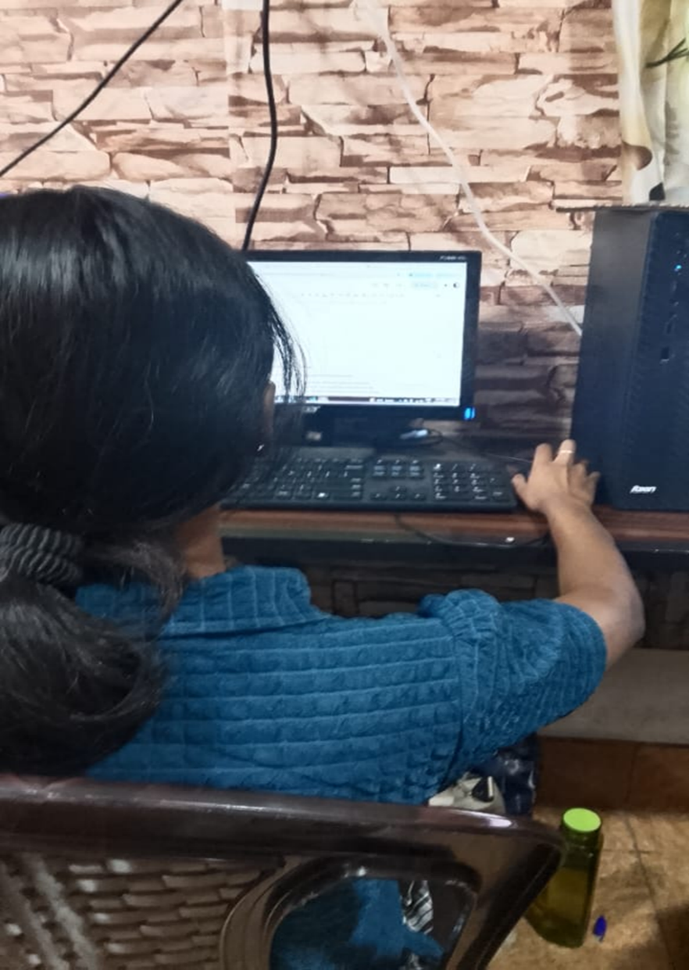
- Workbook summary

This sheet records the daily internship activities, including date, working hours, tasks performed, and completion status. The internship focused on full stack development, covering HTML, HTML tables, Python Django, and project work. Each session was completed successfully with an average of 6 hours of work per day, showing consistent participation and progress throughout the training period.

Click here

